Pipe Capacity & Utilization

User Manual

May 1, 2018


Rev | Description | Date | Prep | Chk'd | Apprv'd
01 | New Document

Revision History
Rev | Description | Section | Pages
01 | New document | - | -

CONTENTS
1 INTRODUCTION 3
2 THEORY 4
3 VM Stress (Riser Code, API-RP-2RD) 4
3.1.1 Combined Stresses 5
3.1.2 Allowable Stresses 5
3.1.3 Allowable Stress in Plain Pipe 5
4 API STD 2RD 6
4.1.1 Burst Pressure 6
4.1.2 Collapse Due to External Pressure 7
4.1.3 Tension 8
4.1.4 Internal Pressure 8
5 API RP 2RD 12
5.1 Combined Stresses 12
5.2 Allowable Stresses 12
5.3 Allowable Stress in Plain Pipe 12
5.4 API RP 2RD.ini 13
6 API 6A 13
7 ASME B31.8 14
7.1.1 Steel Pipe Design Formula 14
8 API 1111 16
8.1.1 Specified Minimum Burst Pressure 16
8.1.2 MOP Limits 17
8.1.3 Internal Pressure (Burst) Design 18
8.1.4 Longitudinal Load Design 18
8.1.5 Combined Load Design 20
9 DNV-OS-F101 20
9.1 Units 20
9.2 DNV-OS-F101.ini 20
9.3 Rigid Pipe 21
9.3.1 Characteristic Material Properties 27
9.3.2 Pressure containment (bursting) 28
10 DNV-OS-F201 (Dynamic risers) 31
10.1.1 Geometrical Parameters 31
10.1.2 Design Load Effects 31
10.1.3 Load Effect Factors 32
10.1.4 Resistance Factors 33
10.2 Bursting 33
10.3 System Hoop Buckling (Collapse) 33
11 Input Data Specification 34
11.1.1 Overview 34
11.1.2 Design Matrix for Rigid Risers 35
12 References. 35
Appendix A – PROGRAM HISTORY 36
Appendix B - ERROR LOG 36
B.1 Calculation Errors 36
Appendix C -test cases. 37
Appendix D validation 37

INTRODUCTION
The codes addressed in the document are:
- API RP 2RD
- API STD 2RD
- DNV OS F1O1
- DNV OS F2O1
- API RP 1111
- API 5C

Codes | Burst | Collapse | Combined Loading
API RP 2RD | ? | ? | ?
API STD 2RD | 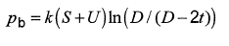 | 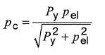 | Method1:  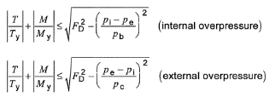  Method2:  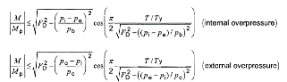  Method 3:  based on DNV-OS-F201  Method 4:  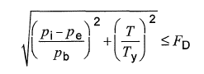
DNV OS F1O1 | 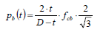 | 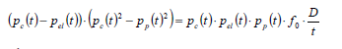 | 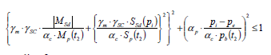
DNV OS F2O1 | 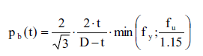 | 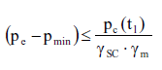 | 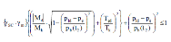
API RP 1111 | 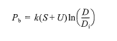
API 5C

THEORY

VM Stress (Riser Code, API-RP-2RD)
- This section applies to metal risers made of steel or titanium.

Primary | Any normal or shear stress that is necessary to have static equilibrium of the imposed forces and moments. A primary stress is not self-limiting. Thus, if a primary stress substantially exceeds the yield strength, either failure or gross structural yielding will occur.
 | Membrane | σp is the average value across the thickness of a solid section excluding the effects of discontinuities and stress concentrations. For example, the general primary membrane stress in a pipe loaded in pure tension is the tension divided by the cross-sectional area. Σp may include global bending as in the case of a simple pipe loaded by a bending moment.
 | Bending | σb is the portion of primary stress proportional to the distance from the centroid  of a cross section, excluding the  effects of discontinuities and stress concentrations.
Secondary | σq is any normal or shear stress that develops as a result of material restraint. This type of stress is self-limiting which means that local yielding can relieve the conditions that cause the stress, and a single application of load will not cause failure.

Table 1 –Stresses To Consider

Combined Stresses
Principal stress components at each critical section should be combined using the von Mises yield criterion defined by the following equation.

$σe= \frac{1}{√2}\sqrt{{\left(σ1-σ2\right)}^{2}+ {\left(σ2-σ3\right)}^{2 }+{\left(σ3-σ1\right)}^{2}}$ (1)
Where
σe = von Mises equivalent stress
σ₁, σ_{2,} σ₃ = Principal stresses.

Allowable Stresses
The von Mises equivalent stresses should be less than the allowable stresses defined by the right hand side of the following inequalities.

$\left(σp\right)e<Cfσa$ (2) $σp+σb)e < 1.5Cf σa$ (3)
$(σp+σb+ σq)e < 3.0 σa$ (4)
Where
σa = Caσy = basic allowable combined stress.
Ca = allowable stress factor, Ca = 2/3
σy = material minimum yield strength, defined for
Steel or titanium as the tensile stress required to
Produce a total elongation of 0.5 percent of the
Test specimen gage length.
Cf = design case factor

Allowable Stress in Plain Pipe
For plain round pipe, where transverse shear and torsion are negligible, the three principal stress components of primary membrane stress (average stress across pipe wall) are σpr, σpθ, and σpz, where r, θ, and z refer to radial, hoop, and axial stresses. Thus,

$\frac{1}{ √2} \sqrt{{\left(σpr-σpθ\right)}^{2}+ {\left(σpθ-σpz\right)}^{2 }+{\left(σpz-σpr\right)}^{2}}<Cfσa$ (5)

For Thick Wall Pipe

$σpr = (PoDo +PiDi)$ (6)
$σpθ = (Pi-Po)\frac{Do}{2t}- Pi$ (7)
$σpz =\frac{T}{A}±\frac{M}{2I}\left(Do-t\right)$ (8)

Where:
Pi = internal pressure.
Po = external pressure.
Do, Di = outside, inside diameters.
t = pipe wall thickness.
A = .
T = true wall tension in pipe at section being analyzed.
M = global bending moment in pipe.
I = moment of inertia = .
Note that the criteria for (σp + σb)e and (σp + σb + σq)e are never controlling for this case.

Substituting Equations 6, 7, and 8 into Equation 5 gives, following a little algebra,

$$σ^{2}e ={\left[\frac{√3(Pi – Po)DoDi)}{2(Do + Di)t}\right]}^{2}+ {\left[\frac{Tef}{A}\frac{+}{-}\frac{M\left(Do-t\right)}{2I} \right]}^{2}≤ (Cf Sa)2$$
Where

T_{eff} = T – P_{i}A_{i} + P_{o}A_{o}

And

A_{i} = πD_{i}² / 4
A_{o} = πD_{o}² / 4.

API STD 2RD

Burst Pressure
The minimum burst pressure of pipe is determined by Equation 1:

$$Pb = k(S +U)ln(D / (D-2t))$$
Where

k is a parameter to account for variability in mechanical properties and wall thickness, and is equal to 0.45 for API 5L or API SeT pipe;
D is the outside diameter of the pipe;
T is the nominal thickness of the pipe reduced for corrosion, wear and/or erosion as appropriate;
S is the specified minimum yield strength of the pipe;
U is the specified minimum ultimate strength of the pipe.

Collapse Due to External Pressure
The collapse pressure for pipes can be calculated as a function of nominal wall thickness as per
Equation 2.

$$Pc=\frac{Py pel}{\sqrt{p^{2}y+p^{2}el}}$$
Where

P y is the yield collapse pressure, given by Equation 3;
Pel is the elastic collapse pressure, given by Equation 4.

$$Py=2S\frac{t}{D}$$
$${Pel}^{\left(t\right)}=\frac{{2E\left(\frac{t}{D}\right)}^{3}}{{1-v}^{2}}$$

Where
E is Young's modulus;
v is Poisson's ratio.

The collapse pressure may alternatively be calculated as a function of the elastic capacity, plastic
Capacity and the Ovality of the pipe.

$$\left(p_{c}-p_{el}\right)\left(p_{c}^{2}-p_{p}^{2}\right)=p_{c}p_{el}p_{p}2δ_{o}\frac{D}{t}$$

Where
$δ_{o}$ is pipe Ovality
Pp is the plastic collapse pressure of a pipe

$$p_{p}=2\frac{t}{D}Sα_{fab}$$
Where

α_{fab} is the fabrication factor

1.0 seamless pipe
α_{fab} = 0.85 UOE pipe
0.925 UO/TRB pipe

The initial departure from circularity of pipe and pipe ends (i.e. the initial ovality).

$$δ_{o}= \frac{D_{max}-D_{min}}{D_{max}+D_{min}}$$

The initial ovality shall not be taken less than 0.0025 (0.25 %). Ovalization caused during the construction and installation phase shall be included in the ovality. The ovalization due to external pressure or moment in the as-installed position shall not be included.

Collapse Due to Pure Bending

Pure bending can result in wrinkling of the pipe wall or flattening of the cross section. Both conditions are known as buckling due to bending. The bending strain that can result in such deformation can be calculated

$$ε_{b}=\frac{t}{2D}$$

Tension
The tension capacity may be calculated by Equation 10.

$$Ty=SA$$
Where

A is the pipe cross-section area, given by Equation 11.

$$A=π\left(D-t\right)t$$

Internal Pressure
The casing pressure equal to the pressure caused by a tubing leak, extreme pressure in a drilling riser, hydrostatic test pressure, incidental pressure, and/or design pressure shall not exceed the pressure determined by Equation 14.

$$Pi-Pe≤FDPb$$
Where

Pe is the external pressure;
Pi is the internal pressure;
F_{D} is a design factor and is given by Equation 15.

0.81 Production casing with tubing leak
0.81 Drilling riser with extreme pressure
F_{D} = 0.90 Hydrostatic test
0.67 Incidental pressure
0.60 Design pressure

Method 1

The load combinations and associated design factors for Method 1 are given in Equations 18 and 19.

$$\left|\frac{T}{Ty}\right|+\left|\frac{M}{My}\right|≤\sqrt{F^{2}D-{\left(\frac{Pi-Po}{Pb}\right)}^{2}}(Internal Pressure)$$
$$\left|\frac{T}{Ty}\right|+\left|\frac{M}{My}\right|≤\sqrt{F^{2}D-{\left(\frac{Po-Pi}{Pc}\right)}^{2}}(external Pressure)$$

Where
T = Ta - PiAj + PeAo is the effective tension in the pipe;
Ta = σaA

σa is the axial stress in the pipe wall;
Ao, is the external cross section of the pipe
A_{i} is the internal cross section of the pipe
M is the moment in the pipe;
F_{D} is a design factor, given by Equation 20.

$$FD=\left\{\begin{matrix}0.80 SLS,ULS interanl and External Overpressure \\ 0.90 ALS external overpressure for Pe-Pi>0.5Pc \\ 1.00 ALS otherwise\end{matrix}\right\}$$

Method 2

Method 2 limits axial load based on yield tension including the effect of internal pressure. The load combinations and associated design factors

$$\left|\frac{M}{Mp}\right|≤\sqrt{F^{2}D-{\left(\frac{Pi-Pe}{Pb}\right)}^{2}}cos\left(\frac{π}{2} \frac{\frac{T}{Ty}}{\sqrt{F^{2}D}-{\left(\frac{\left(Pi-pe\right)}{Pb}\right)}^{2}}\right)(Internal Over pressure)$$

$$\left|\frac{M}{Mp}\right|≤\sqrt{F^{2}D-{\left(\frac{Pe-Pi}{Pc}\right)}^{2}}cos\left(\frac{π}{2} \frac{\frac{T}{Ty}}{\sqrt{F^{2}D}-{\left(\frac{\left(Pe-pi\right)}{Pc}\right)}^{2}}\right)(Internal Over pressure)$$

Where

FD is a design factor,

0.80 SLS, ULS
FD =
- ALS

Method 3

Method 3 is based on DNV-OS-F201, which uses a load and resistance factor design (LRFD) format. For load controlled conditions, refer to the section in F201 on Combined Load Criteria for Riser Pipes. For displacement controlled conditions, refer to the F201 section labeled Displacement Controlled Conditions. When the calculated moment exceeds 90 % of the plastic moment,

Method 4

Method 4 sets limits on combined axial load and pressure, without considering bending. Refer to API 1111 for further explanation. Bending limits are set based on bending strain.
NOTE there are cases such that the plastic moment limit set by Method 2 does not result in excessive bending strain (Le. the loading condition is displacement controlled).

The load combinations and associated criteria are given by

$$\sqrt{{\left(\frac{pi-pe}{pb}\right)}^{2}+{\left(\frac{T}{Ty}\right)}^{2}}≤FD$$
Where

FD is a design factor,

0.80 SLS, ULS
FD =
- ALS

For sizing, limiting the load combination in Equation 24 to 0.67 (F D = 0.67) using static effective tension and normal operating pressure will usually provide a design that meets SLS, ULS and ALS conditions.
Method 4 sets limits for bending strain for cases of internal or external overpressure. The criteria are given by

ε ≤ F Dεb (internal overpressure)

$$ε≤\frac{Fdεb}{1+20δo}\left(1-\frac{pe-Pi}{FcPc}\right) (External pressure)$$
Where

c is the bending-induced strain in the pipe;
F D is a design factor;
fc is the collapse factor for use with combined pressure and bending loads; see Equation 29.
0.5 SLS, ULS
FD =
- ALS

0.6 cold expanded pipe (e.g. DSAW)
Fc = 0.7 seamless pipe

Temperature Derating
Temperature derating conducted based on the DNV-OS-F201

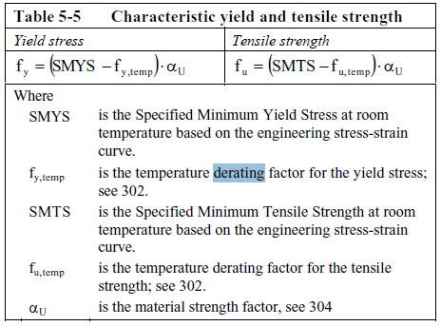
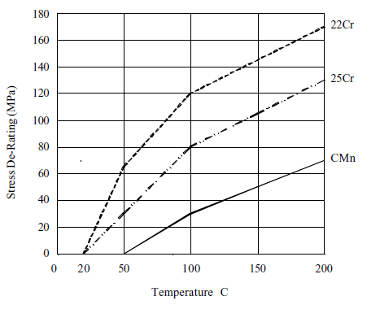
Figure 4-1 Derating Value for Yield Strength

API RP 2RD

Combined Stresses
Principal stress components at each critical section should be combined using the von Mises yield criterion defined by the following equation.

$$σ_{e}=\frac{1}{\sqrt{2}}\sqrt{{\left(σ_{1}-σ_{1}\right)}^{2}+{\left(σ_{2}-σ_{3}\right)}^{2}+{\left(σ_{3}-σ_{1}\right)}^{2}}$$
Where
σe = von Mises equivalent stress.
σ1, σ2, σ3 = principal stresses.

Allowable Stresses
The von Mises equivalent stresses should be less than the allowable stresses defined by the right hand side of the following inequalities.

$${\left(σ_{p}\right)}_{e}<C_{f}σ_{a}$$

$${(σ_{p}+σ_{b} )}_{e}<1.5C_{f}σ_{a}$$

$${(σ_{p}+σ_{b}+σ_{q} )}_{e}<3.0σ_{a}$$

where
σ_{a} = C_{a}σ_{y} = basic allowable combined stress.
C_{a} = allowable stress factor, Ca = 2/3
σ_{y} = material minimum yield strength, defined for steel or titanium as the tensile stress required to produce a total elongation of 0.5 percent of the test specimen gage length.
C_{f} = design case factor.

Allowable Stress in Plain Pipe
For plain round pipe, where transverse shear and torsion are negligible, the three principal stress components of primary membrane stress (average stress across pipe wall) are σ_{pr}, σ_{pθ}, and σ_{pz}, where r, θ, and z refer to radial, hoop, and axial stresses.

$$\frac{1}{\sqrt{2}}\sqrt{{\left(σ_{pr}-σ_{pθ}\right)}^{2}+{\left(σ_{pθ}-σ_{pz}\right)}^{2}+{\left(σ_{pz}-σ_{pr}\right)}^{2}≤C_{f}σ_{a}}$$

Moreover, for a thick walled pipe,

$$σ_{pr}=-\frac{\left(P_{o}D_{o}+P_{i}D_{i}\right)}{D_{o}+D_{i}}$$

$$σ_{pθ}=\left(P_{i}-P_{o}\right)\frac{D_{o}}{2t}-P_{i}$$

$$σ_{pz}=\frac{T}{A}±\frac{M}{2I}\left(D_{o}-t\right)$$

Where

Pi = internal pressure.
Po = external pressure.
Do, Di = outside, inside diameters.
t = pipe wall thickness.
A = $\frac{π}{4}\left({D_{o}}^{2}-{D_{i}}^{2}\right)$
T = true wall tension in pipe at section being analysed.
M = global bending moment in pipe.
I = moment of inertia = $\frac{π}{64}\left({D_{o}}^{4}-{D_{i}}^{4}\right)$
Note that the criteria for (σ_{p} + σ_{b})_{e} and (σ_{p} + σ_{b} + σ_{q})_{e} are never controlling for this case.

API RP 2RD.ini
Python Code | Code | Reference/ Notes | Units
[codeParameterInput]
AllowableStressFac=0.666
DesignCaseFac=1
[pipeInput]
NominalOD=0.24765
NominalWT=0.034925
MinimumWT=0.03492
NominalID=0.1778
[loadingData]
ExternalPressure=0
InternalPressure=0
TensionEffective=0
Moment=-460000
[Material Properties]
YieldStrength = 80

API 6A
Calculation for pressure vessels subjected to stress from internal pressure, axial loads and an external bending moment.

Material | API
S_{y} | 80000 psi
S_{yt} | 80000 psi
S_{ut} | 95000 psi
Table 2 Material Data

Design Stress intensity at Operating Condition
$$Sm=min\left(\frac{2}{3} . Sy,\frac{1}{2} . Sut\right) If Material = “NS” = 53333 psi$$
2/3.Sy otherwise

Maximum Stress Intensity at Hydrotest Condition

$$Sl=min\left(\frac{5}{6} . Syt,\frac{2}{3} . Sut\right) If Material =“NS"= 66666.7 psi$$
5/6.Syt otherwise

Maximum Combined Primary and Secondary Stress Intensity

$$Ss=min(2 . Sy,1 . Sut) If Material = “NS” = 160000psi$$
2.Sy otherwise

ASME B31.8

Steel Pipe Design Formula
The design pressure for steel gas piping systems or the nominal wall thickness for a given design pressure shall be determined by the following formula (for limitations).

$$P=\frac{2St}{D} FET$$
Where

D nominal outside diameter of pipe, in.
E longitudinal joint factor obtained
F design factor obtained
P design pressure
S specified minimum yield strength, psi, stipulated in the specifications under which the pipe was purchased from the manufacturer or determined in accordance
T temperature derating factor obtained
t nominal wall thickness, in.

Plastic Pipe and Tubing Design Formula.

The design pressure for plastic gas piping systems or the nominal wall thickness for a given design pressure
$$p=2S\frac{t}{(D-t)}*0.32$$
D = Specified Outside Diameter,in
P = Design pressure, psig
S = for thermoplastic pipe and tubing, long-term hydrostatic strength determined in accordance with the listed specification at a temperature equal to 73°F, lOO°F, 120°F, or 140oP; for reinforced thermosetting plastic pipe, use 11,000 psi
t = specified wall thickness,in.

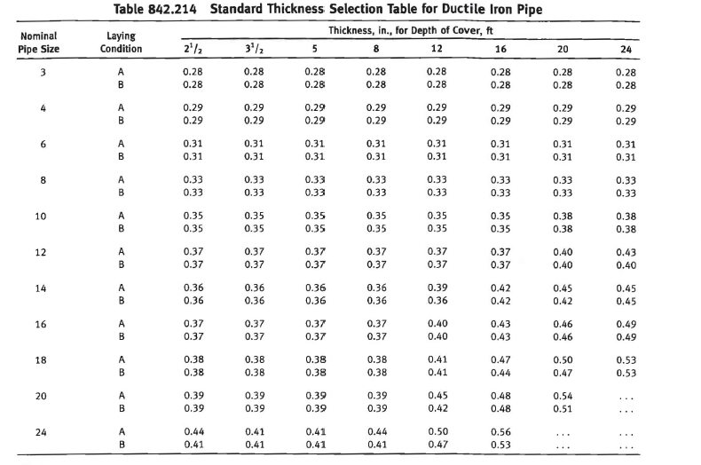
Figure 7-1 Standard Thickness Selection Table for Ductile Iron Pipe
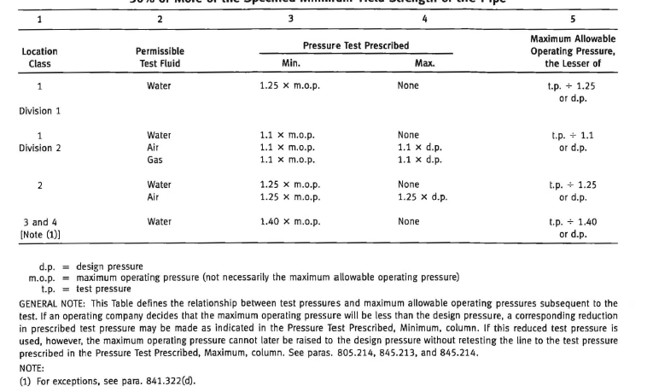
Figure 7-2 Test Requirements for Pipelines and Mains to Operate at Hoop Stresses of
30% or More of the Specified Minimum Yield Strength of the Pipe

API 1111
Pipe selection for most offshore pipelines is determined by considering installation and operation loads in addition to the stresses resulting from internal pressure. Design should begin with material selection and pipe sizing for flow considerations and be modified later as a result of design cycles that include the following:
a) Burst due to net internal pressure;
b) Combined bending and tension during installation and operation;
c) Collapse due to external pressure, with the pipe either empty or filled;
d) Buckling and collapse due to combined bending and external pressure;
e) Pipeline stability against horizontal or vertical displacement during construction and operation;
f) Effects of thermal expansion and contraction;
g) in-place and in-service pipeline repair capabilities;

Specified Minimum Burst Pressure
The specified minimum burst pressure may be written in the form:
$$Pb = k(S +U)ln(D / (D_{i}))$$

Where:

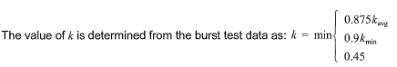

MOP Limits
The MOP should not exceed any of the following:
a) the design pressure of any component, including pipe, valves, and fittings;
b) 80 % of the applied hydrostatic test pressure in accordance with 8.2.
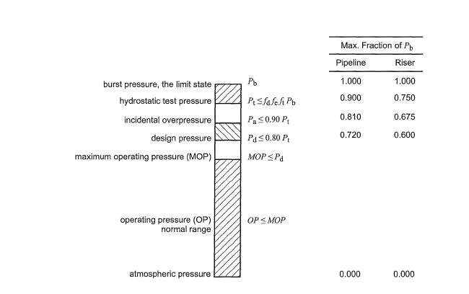
Figure 8-1 Pressure Level Relations

Internal Pressure (Burst) Design
The hydrostatic test pressure, the pipeline design pressure, and the incidental overpressure, including both internal and external pressures acting on the pipelines, shall not exceed that determined by the equations.

$$Pt≤fdfeftPb$$

$$Pd≤0.80Pt$$

$$Pa≤0.90Pt$$
Where
f_{d} is the internal pressure (burst) design factor, applicable to all pipelines;
0.90 for pipelines;
0.75 for pipeline risers.
f_{e} is the weld joint factor, longitudinal or spiral seam welds. See ASME 831.4 or ASME 831.8. Only materials with a factor of 1.0 are acceptable.
f_{t} is the temperature derating factor, as specified in ASME 831.8 [1.0 for temperatures less than 121°C (250 OF)].
Pa is the incidental over pressure (internal minus external pressure), in N/mm2 (psi).
Pb is the specified minimum burst pressure of pipe, in N/mm2 (psi).
Pd is the pipeline design pressure, in N/mm2 (psi).
Pt is the hydrostatic test pressure (internal minus external pressure), in N/mm2 (psi).

The specified minimum burst pressure (Pb) is determined by one of the following equations:

$$Pb = 0.45\left(S+ U\right)ln\frac{D}{Di}, or$$

$$Pb = 0.90(S + U)\frac{t}{D-t}$$
Where
D is the outside diameter of pipe, in mm (in.);
Di is D - 2t = inside diameter of pipe, in mm (in.);
S is the specified minimum yield strength (SMYS) of pipe, in N/mm2 (psi) (see API 5L, ASME 831.4, or ASME 831.8 as appropriate);
t is the nominal wall thickness of pipe, in mm (in.);
U is the specified minimum ultimate tensile strength of pipe, in N/mm2 (psi);
tn is the natural log.

Longitudinal Load Design
The effective tension due to static primary longitudinal loads (see 4.6.2) shall not exceed the value given by.

$$Teff≤0.60Ty$$
Where

$$Teff=Ta-PiAi+PoAo$$

$$Ta=σaA$$

Ty=SA

$$A=Ao-Ai=\frac{π}{4}\left(D^{2}-{Di}^{2}\right)$$

A is the cross-sectional area of pipe steel, in mm2 (in. 2);
Ai is the internal cross-sectional area of the pipe, mm2 (in. 2);
Ao is the external cross-sectional area of the pipe, mm2 (in. 2);
Pi is the internal pressure in the pipe, in N/mm2 (psi);
Po is the external hydrostatic pressure, in N/mm2 (psi);
Ta is the axial (material) tension in pipe, in N (Ib);
Teff is the effective tension in pipe, in N (Ib);
Ty is the yield tension of the pipe, in N (Ib);
O"a is the axial stress in the pipe wall, in N/mm2 (psi).
The physical meaning of the term "effective" tension relates to the interaction between the pipe and other structures (sleds, anchor points, lay barge hangoff, etc.). The applied force at a boundary condition is always the effective tension. For the on-bottom portion of a pipeline, the effective tension will vary as loading conditions change. Typically, when a pipeline is just installed on the seabed, the effective tension is equal to the residual horizontal lay tension. For
a single pipeline under fully restrained condition (i.e. far from the end), the effective tension Teff is given by:

$$Teff=Tlay-\left(1-2v\right)∆PiAi-AE∝∆T$$
Where

Tlay is the residual lay tension;
in the case of a pipe-in-pipe (PIP) installed with the inner pipe free-standing inside the outer pipe during construction, the term 11ay will be negative (without mitigation) and additive to pressure and temperature loading.
∆Pi is the internal pressure change since laydown of the pipe;
E is Young's modulus of elasticity;
∝ is the thermal coefficient of expansion of the pipe;
∆T is the temperature change in the pipe since laydown;
v is the poisson ratio.

Combined Load Design
The combination of primary longitudinal load (static and dynamic) and differential pressure load shall not exceed that given by:

$\sqrt{{\left(\frac{Pi-Po}{Pb}\right)}^{2}+{\left(\frac{Teff}{Ty}\right)}^{2}}≤ \left[\begin{matrix}0.90 \\ 0.96 \\ 0.96\end{matrix}\right] \left[\begin{matrix}For operational loads \\ For Extreme Loads \\ For hydrotest Loads\end{matrix}\right]$52

DNV-OS-F101
The DNV-OS-F101 subsea pipeline design code is implemented as python program to help check pipeline design. The code from the design guideline and program implemented are summarized in this section.

Units
Ovality | #
loadTemperature | Deg C
loadPressure | Psi
loadEffectiveTension | KN
loadBendingMoment | kN-m

units = {'ovality': '#', 'loadTemperature' : 'deg C', "loadPressure": "psi",
"loadEffectiveTension": "kN", "loadBendingMoment": "kNm"}

DNV-OS-F101.ini
Python Code | Code | Reference/ Notes | Units
[materialResistanceFactors]  SLS = 1.15  ULS = 1.15  ALS = 1.15  FLS = 1.00 | 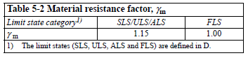 | Sec 5  C 203 | #
[pressureContainment]  safetyClass = {"low": 1.046, "medium" : 1.138, "high" : 1.308}  [other]  safetyClass = {"low": 1.04, "medium" : 1.14, "high" : 1.26} | 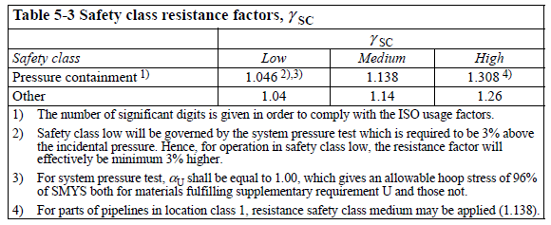 | Sec 5  C 204 | #
[materialStrengthFactors]  Normally = 0.96  suplementaryRequirement = 1.00 | 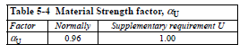 | Sec 5  C306 | #
[materialFabrication]  factors = {"Seamless": 0.96, "UO" : 1.00, "TRB" : 0.93, "ERW" : 0.93, "UOE" : 0.85} | 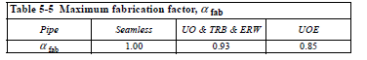 | Sec 5  C307 | #
[pressureTestSafetyFactors]  mill = {"low": 1.0, "medium" : 1.088, "high" : 1.251}  system = {"low": 1.03, "medium" : 1.05, "high" : 1.05} | 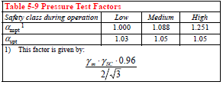 | Sec 5  D201 | #
[loadEffectFactors]  values = {"ULS": {"functional": 1.2, "environmental" : 0.7, "interference" : 0.0, "accidental" : 0.0},  "ULS_Local" : {"functional": 1.1, "environmental" : 1.3, "interference" : 1.1, "accidental" : 0.0},  "FLS" : {"functional": 1.0, "environmental" : 1.0, "interference" : 1.0, "accidental" : 0.0},  "ALS" : {"functional": 1.0, "environmental" : 1.0, "interference" : 1.0, "accidental" : 1.0} } | 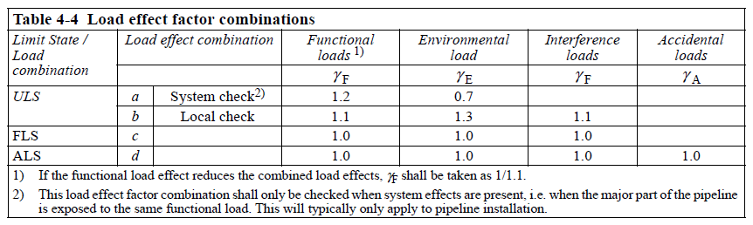 | Sec 4  G 303 | #
[conditionloadEffectFactors]  Pipelinerestingonunevenseabed = 1.07  reelingonandj-tubepullin = 0.82  systempressuretest = 0.93  otherwise = 1.0 | 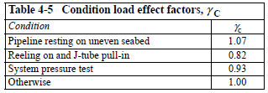 | Sec 4  G 304 | #
[resistanceFactors]  safetyClass= 1.046  environmental = 1.1  interference = 1.0  accidental = 1.0  gammae = {"low": 2.0, "medium" = 2.5, "high" = 3.3} | ??  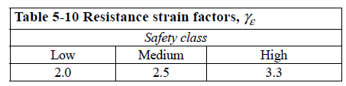 | Sec ?  Sec 5  D 609 | #
[load]  values = { "effectiveTension" : {"functional" : 0, "environmental" : 0, "interference" : 0, "accidental" : 0},  "bendingMoment" : {"functional" : -100.00, "environmental" : -639.5, "interference" : 0, "accidental" : 0},  "strain" : {"functional" : 0.01, "environmental" : 0.01, "interference" : 0.001, "accidental" : 0.001} } | Input loading | Sec ?
[loadPressure]  designInternal =3  fluidTemperature = 25  internal = 3  external=0.5  pbt1=1  plt=1.5  ph=1.1  pli=1.75  minimumInternal=0 | Input loading | Sec ?
[loadTemperature]  fluid = 25 | Input loading | Sec ?

Rigid Pipe
 |  | Reference
def DNVThickness(self):  self.thickness1["installation"] = self.nominalWallThickness - self.thicknessFabricationTolerance  self.thickness1["operation"] = self.nominalWallThickness - self.thicknessFabricationTolerance - self.corrosionAllowance  self.thickness2["installation"] = self.nominalWallThickness  self.thickness2["operation"] = self.nominalWallThickness - self.corrosionAllowance  self.thickness3["installation"] = self.nominalWallThickness  self.thickness3["operation"] = self.nominalWallThickness - 0.5 * self.corrosionAllowance | 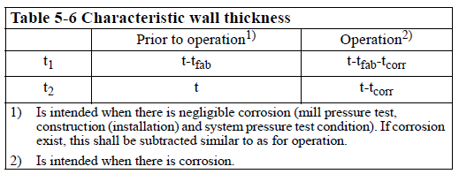 | Sec 5  C 401
def updateThicknessFabricationTolerance(self, thicknessFabricationTolerance = None):  if self.thicknessFabricationTolerance is None:  self.thicknessFabricationTolerance = thicknessFabricationTolerance | Update the wall thickness fabriation tolerance with user specific values | NA
def updateCorrosionAllowance(self, CorrosionAllowance = None):  if self.corrosionAllowance is None:  self.corrosionAllowance = CorrosionAllowance | Update the Corrosion Allowance with user specific values | NA
def updateErosionAllowance(self, ErosionAllowance = None):  if self.erosionAllowance is None:  self.erosionAllowance = ErosionAllowance | Update the Erosion Allowance with user specific values | NA
def pressureContainmentResistance(self, thickness = None):  yield_ContainmentOrBurst = min(self.Parameters.materialProperties.specifiedMinimumYieldStrength, self.Parameters.materialProperties.specifiedMinimumTensileStrength/1.15)  if thickness is None:  self.pressureContainmentResistance = 2 * self.nominalWallThickness / (self.nominalDiameter - self.nominalWallThickness) *yield_ContainmentOrBurst*2/math.sqrt(3)  else:  self.pressureContainmentResistance = 2 * thickness / (self.nominalDiameter - thickness) *yield_ContainmentOrBurst*2/math.sqrt(3) | 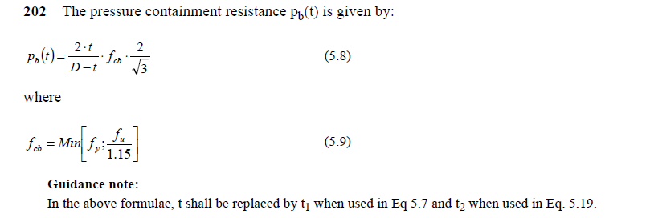 | Sec 5  D 202
# ACTION : Need formulas for plt and ph  def pressureContainment(self, operatingCondition, safetyClass="high", limitState="ULS"):  thickness = self.thickness1[operatingCondition]  self.pressureContainmentResistance(thickness)  quantity1 = self.pressureContainmentResistance / self.Parameters.pressureTestSafetyFactors.system[safetyClass] / self.Parameters.materialResistanceFactors[limitState]  quantity2 = self.Parameters.loadPressure.plt / self.Parameters.pressureTestSafetyFactors.system[safetyClass] - self.Parameters.loadPressure.external  quantity3 = self.Parameters.loadPressure.ph * self.Parameters.materialStrengthFactors.Normally / self.Parameters.pressureTestSafetyFactors.mill[safetyClass]  LHS = self.Parameters.loadPressure.pli - self.Parameters.loadPressure.external  RHS = min(quantity1, quantity2, quantity3)  self.incidentPressureburstcheckMargin = (RHS - LHS) / RHS  if LHS <= RHS:  self.incidentPressureburstCheckPass = True  else:  self.incidentPressureburstCheckPass = False  LHS = self.Parameters.loadPressure.plt - self.Parameters.loadPressure.external  RHS = min(quantity1, self.Parameters.loadPressure.ph)  self.incidentPressureburstcheckMargin = (RHS - LHS) / RHS  if LHS <= RHS:  self.testPressureburstCheckPass = True  else:  self.testPressureburstCheckPass = False | 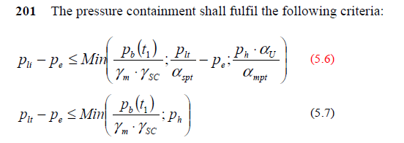 | Sec 5  D 201
# ACTION: Find reference for ovality per DNV standards. Default is 3%  def updateOvality(self, Dmax = None, Dmin = None):  if self.ovality is None:  if (Dmax == None) or (Dmin == None):  self.ovality = self.Parameters.defaults.ovality  else:  self.ovality = (Dmax - Dmin)/self.nominalDiameter  if self.ovality < 0.005:  self.ovality = 0.005 | 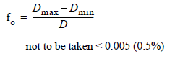 | Sec 5  D 402
# Temperature Derating  def temperatureDeratingValues(self, fluidTemperature = None):  if fluidTemperature is None:  if (self.Parameters.loadPressure.fluidTemperature > self.Parameters.materialProperties.temperatureDerateLimit):  self.fy_temp = 1.14 - self.Parameters.loadPressure.fluidTemperature / 850 # Temperature Derating Factor for the Yield Stress.  # Action: Add ultimate Stress drating  self.fu_temp = self.fy_temp  else:  self.fy_temp = 0 # Temperature Derating Factor for the Yield Stress  self.fu_temp = self.fy_temp  else:  if fluidTemperature > self.Parameters.materialProperties.temperatureDerateLimit:  self.fy_temp = 1.14 - fluidTemperature / 850 # Temperature Derating Factor for the Yield Stress  # Add ultimate Stress drating  self.fu_temp = self.fy_temp  else:  self.fy_temp = 0 # Temperature Derating Factor for the Yield Stress  self.fu_temp = self.fy_temp |  | Sec  8.3.1
# Material strength values and derated values  def updateStrengthValues(self,specifiedMinimumYieldStrength=None, specifiedMinimumTensileStrength=None):  if specifiedMinimumYieldStrength is not None:  self.Parameters.materialProperties.specifiedMinimumYieldStrength = specifiedMinimumYieldStrength  self.minimumYieldStrength = (self.Parameters.materialProperties.specifiedMinimumYieldStrength - self.fy_temp)*self.Parameters.materialStrengthFactors.Normally  if specifiedMinimumYieldStrength is not None:  self.Parameters.materialProperties.specifiedMinimumTensileStrength = specifiedMinimumTensileStrength  self.minimumTensileStrength = (self.Parameters.materialProperties.specifiedMinimumTensileStrength - self.fu_temp)*self.Parameters.materialStrengthFactors.Normally |  | Sec?  C306
# DNV-OS-F101, Section 13 D700, Local Buckling - Collapse Check.  def collapse(self, thickness, pipeFabricationMethod):  self.dOverTRatio = self.nominalDiameter / thickness  self.tOverDRatio = 1/self.dOverTRatio  self.elasticCollapseCapacity = 2*self.Parameters.materialProperties.youngsModulus*self.tOverDRatio**3/(1-self.Parameters.materialProperties.poissionsratio**2)  self.plasticCollapseCapacity = self.minimumYieldStrength*self.Parameters.materialFabrication.factors[pipeFabricationMethod]*2*self.tOverDRatio  b = -self.elasticCollapseCapacity  c = -(self.plasticCollapseCapacity**2 + self.plasticCollapseCapacity*self.elasticCollapseCapacity*self.ovality*self.dOverTRatio)  d = self.elasticCollapseCapacity*(self.plasticCollapseCapacity**2)  u = 1/3 * (-b**2/3 + c)  v = 1/2 * (2/27*(b**3) - b*c/3 + d)  phi= math.acos(-v/math.sqrt(-u**3))  y = -2 * math.sqrt(-u) * math.cos(phi/3+ 60*math.pi/180)  self.collapsePressure = y-b/3 | 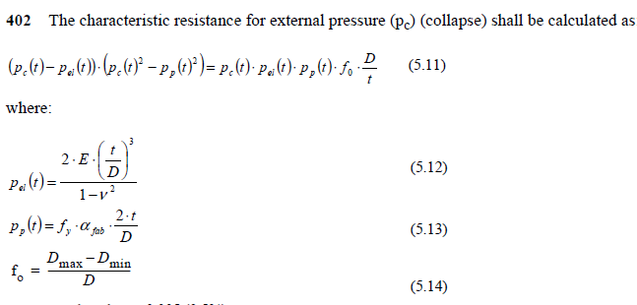 | Sec 5  D 402
def localBucklingUnderExternalPressure(self, thickness, pipeFabricationMethod, safetyClass="high", limitState="ULS"):  # Evalaute collapse pressure  self.collapse(thickness, pipeFabricationMethod)  LHS = self.Parameters.loadPressure.external - self.Parameters.loadPressure.minimumInternal  RHS = self.collapsePressure/self.Parameters.other.safetyClass[safetyClass]/self.Parameters.materialResistanceFactors[limitState]  self.localBucklingExternalPressureCheckMargin = (RHS - LHS) / RHS  if LHS <= RHS:  self.localBucklingExternalPressureCheckPass = True  else:  self.localBucklingExternalPressureCheckPass = False | 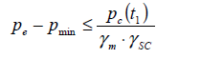 | Sec 5  D 401
def localBucklingUnderExternalPressure_polyMethod(self, thickness, pipeFabricationMethod):  self.collapse(thickness, pipeFabricationMethod)  coefficientX3 = 1  coefficientX2 = -self.elasticCollapseCapacity  coefficientX1 = -(self.plasticCollapseCapacity**2 + self.elasticCollapseCapacity*self.plasticCollapseCapacity*self.ovality*self.dOverTRatio)  coefficientX0 = self.elasticCollapseCapacity * self.plasticCollapseCapacity**2  polynomialCoefficients = [coefficientX3, coefficientX2, coefficientX1, coefficientX0]  potentialRoots = solvePolynomialEquation(polynomialCoefficients)  print(potentialRoots) | Not used. Another method to find roots for a polynomial equation
def propagationBuckling(self, thickness, pipeFabricationMethod, safetyClass="high", limitState="ULS", pipeCondition="Cold"):  # Update the wall thickness ratio for provided wall thickness  self.collapse(thickness, pipeFabricationMethod)  if pipeCondition == "Cold":  yieldStrength = self.Parameters.materialProperties.specifiedMinimumYieldStrength  else:  yieldStrength = self.minimumYieldStrength  if self.dOverTRatio < 15 or self.dOverTRatio < 45:  self.propagationPressure = 35*yieldStrength * self.Parameters.materialFabrication.factors[pipeFabricationMethod] * (self.tOverDRatio**2.5)  else:  self.propagationPressure = None  if self.propagationPressure is not None:  LHS = self.Parameters.loadPressure.external - self.Parameters.loadPressure.minimumInternal  RHS = self.propagationPressure / self.Parameters.other.safetyClass[safetyClass]/self.Parameters.materialResistanceFactors[limitState]  self.propagationBucklingCheckMargin = (RHS - LHS) / RHS  if LHS <= RHS:  self.propagationBucklingCheckPass = True  else:  self.propagationBucklingCheckPass = False  else:  self.propagationBucklingCheckMargin = None  self.propagationBucklingCheckPass = "Pipe out of code limits. Detailed FEA may be required to ascertain pipe bending capacity" | 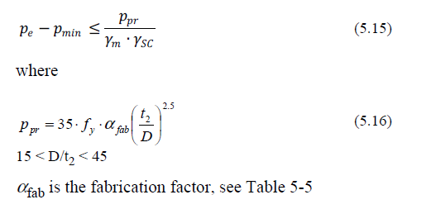 | Sec 5  D 501
# Action : Add buckle arrestor capacity design equations  TBA | 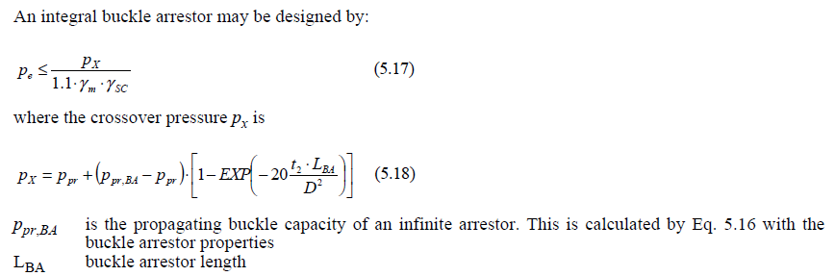 | Sec 5  D 502
def localBucklingCombinedLoadingLoadControlled(self, thickness, pipeFabricationMethod, operatingCondition, safetyClass="high", limitState="ULS", pipeCondition="Cold", conditionEffect ="Other"):  # Update the wall thickness ratio for provided wall thickness  self.collapse(thickness, pipeFabricationMethod)  # self.pressureContainment(operatingCondition, safetyClass)  pInternal = self.Parameters.loadPressure.internal  pExternal = self.Parameters.loadPressure.external  if (pInternal >= pExternal):  logging.critical("Internal Overpressure")  overPressureRatio = (pInternal - pExternal)/self.pressureContainmentResistance  else:  logging.critical("External Overpressure")  overPressureRatio = (pExternal - self.Parameters.loadPressure.minimumInternal)/self.collapsePressure  if pipeCondition == "Cold":  yieldStrength = self.Parameters.materialProperties.specifiedMinimumYieldStrength  else:  yieldStrength = self.minimumYieldStrength  gammac = self.Parameters.conditionLoadEffectFactors.values[conditionEffect]  Msd1 = self.Parameters.load.values["bendingMoment"]["functional"] * self.Parameters.loadEffectFactors.values[limitState]["functional"] * gammac + \  self.Parameters.load.values["bendingMoment"]["environmental"] * self.Parameters.loadEffectFactors.values[limitState]["environmental"] + \  self.Parameters.load.values["bendingMoment"]["interference"] * self.Parameters.loadEffectFactors.values[limitState]["interference"] * gammac + \  self.Parameters.load.values["bendingMoment"]["accidental"] * self.Parameters.loadEffectFactors.values[limitState]["accidental"] * gammac  Ssd1 = self.Parameters.load.values["effectiveTension"]["functional"] * self.Parameters.loadEffectFactors.values[limitState]["functional"] * gammac + \  self.Parameters.load.values["effectiveTension"]["environmental"] * self.Parameters.loadEffectFactors.values[limitState]["environmental"] + \  self.Parameters.load.values["effectiveTension"]["interference"] * self.Parameters.loadEffectFactors.values[limitState]["interference"] * gammac + \  self.Parameters.load.values["effectiveTension"]["accidental"] * self.Parameters.loadEffectFactors.values[limitState]["accidental"] * gammac  Msd2 = self.Parameters.load.values["bendingMoment"]["functional"] / self.Parameters.loadEffectFactors.values[limitState]["functional"] * gammac + \  self.Parameters.load.values["bendingMoment"]["environmental"] * self.Parameters.loadEffectFactors.values[limitState]["environmental"] + \  self.Parameters.load.values["bendingMoment"]["interference"] * self.Parameters.loadEffectFactors.values[limitState]["interference"] * gammac + \  self.Parameters.load.values["bendingMoment"]["accidental"] * self.Parameters.loadEffectFactors.values[limitState]["accidental"] * gammac  Ssd2 = self.Parameters.load.values["effectiveTension"]["functional"] / self.Parameters.loadEffectFactors.values[limitState]["functional"] * gammac + \  self.Parameters.load.values["effectiveTension"]["environmental"] * self.Parameters.loadEffectFactors.values[limitState]["environmental"] + \  self.Parameters.load.values["effectiveTension"]["interference"] * self.Parameters.loadEffectFactors.values[limitState]["interference"] * gammac + \  self.Parameters.load.values["effectiveTension"]["accidental"] * self.Parameters.loadEffectFactors.values[limitState]["accidental"] * gammac  self.Msd = max(Msd1, Msd2)  self.Ssd = max(Ssd1, Ssd2)  plasticTensionCapacity = yieldStrength * math.pi * (self.nominalDiameter - thickness) * thickness  plasticMomentCapacity = yieldStrength * math.pi * ((self.nominalDiameter - thickness)**2) * thickness  beta = (60 - self.dOverTRatio) / 90  alphaC = (1-beta) + beta*(self.Parameters.materialProperties.tensileStrength)/yieldStrength  if overPressureRatio < 2/3:  alphaP = 1 - beta  else:  alphaP = 1 - 3*beta*(1-overPressureRatio)  LHS_Term1a = self.Parameters.other.safetyClass[safetyClass]/self.Parameters.materialResistanceFactors[limitState]*self.Msd/alphaC/plasticMomentCapacity  LHS_Term1b = self.Parameters.other.safetyClass[safetyClass]/self.Parameters.materialResistanceFactors[limitState]*self.Ssd/alphaC/plasticTensionCapacity  if (pInternal >= pExternal):  LHS_Term2 = alphaP/alphaC * overPressureRatio  else:  LHS_Term2 = self.Parameters.other.safetyClass[safetyClass]/self.Parameters.materialResistanceFactors[limitState] * overPressureRatio  interactionRatio = (LHS_Term1a + LHS_Term1b ** 2)**2 + LHS_Term2 **2  RHS = 1  if (self.dOverTRatio <= 15) or (self.dOverTRatio <= 45):  logging.critical("CAUTION: D/t ratio outside of code limits. Adjust platic loads with FEA findings prior to use")  if (self.Ssd/plasticTensionCapacity >= 0.4):  logging.critical("CAUTION: Tension loading ratio outside of code limits. Refer to code")  self.localBucklingCombinedLoadingLoadControlledCheckMargin = (RHS - interactionRatio) / RHS  if interactionRatio <= RHS:  self.localBucklingCombinedLoadingLoadControlledCheckPass = True  else:  self.localBucklingCombinedLoadingLoadControlledCheckPass = False | Internal Overpressure  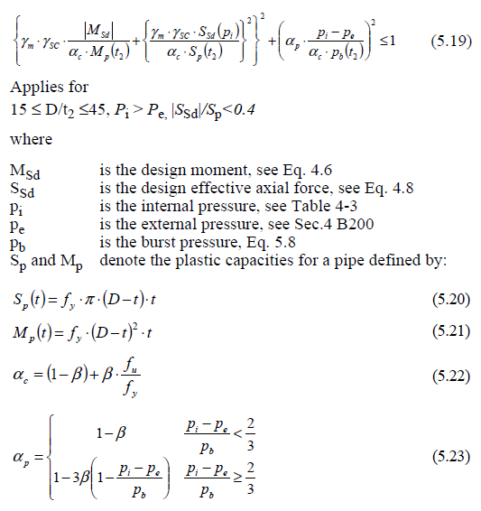  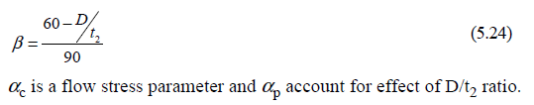  External Overpressure  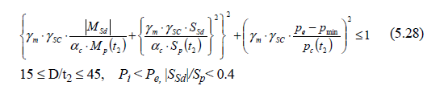 | Sec5  D 605  Sec 5  D 607
Point Load considerations  TBA | 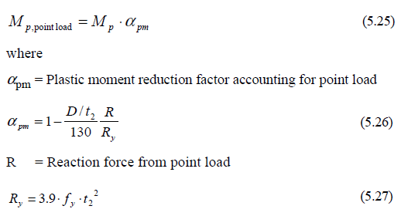 | Sec 5  D 606
def localBucklingCombinedLoadingDisplacementControlled(self, thickness, pipeFabricationMethod, operatingCondition, safetyClass="high", limitState="ULS", pipeCondition="Cold", conditionEffect ="Other"):  # Update the wall thickness ratio for provided wall thickness  self.collapse(thickness, pipeFabricationMethod)  logging.critical("Update alphah in .ini file to re-run Displacement controlled method")  if (self.dOverTRatio <= 45):  logging.critical("CAUTION: D/t ratio outside of code limits. Refer to Code")  gammac = self.Parameters.conditionLoadEffectFactors.values[conditionEffect]  esd1 = self.Parameters.load.values["strain"]["functional"] * self.Parameters.loadEffectFactors.values[limitState]["functional"] * gammac + \  self.Parameters.load.values["strain"]["environmental"] * self.Parameters.loadEffectFactors.values[limitState]["environmental"] + \  self.Parameters.load.values["strain"]["interference"] * self.Parameters.loadEffectFactors.values[limitState]["interference"] * gammac + \  self.Parameters.load.values["strain"]["accidental"] * self.Parameters.loadEffectFactors.values[limitState]["accidental"] * gammac  esd2 = self.Parameters.load.values["strain"]["functional"] / self.Parameters.loadEffectFactors.values[limitState]["functional"] * gammac + \  self.Parameters.load.values["strain"]["environmental"] * self.Parameters.loadEffectFactors.values[limitState]["environmental"] + \  self.Parameters.load.values["strain"]["interference"] * self.Parameters.loadEffectFactors.values[limitState]["interference"] * gammac + \  self.Parameters.load.values["strain"]["accidental"] * self.Parameters.loadEffectFactors.values[limitState]["accidental"] * gammac  esd = max(esd1, esd2)  pInternal = self.Parameters.loadPressure.internal  pExternal = self.Parameters.loadPressure.external  if (pInternal >= pExternal):  ec = 0.78 * (self.tOverDRatio - 0.01) * (1 + 5.75 * (self.Parameters.loadPressure.minimumInternal - pExternal)/self.pressureContainmentResistance ) * self.Parameters.defaults.alphah**-1.5 * self.Parameters.defaults.alphagw  logging.critical("Internal Overpressure")  self.localBucklingCombinedLoadingDisplacementControlledCheckMargin = (esd - ec) / ec  if esd <= ec:  self.localBucklingCombinedLoadingDisplacementControlledCheckPass = True  else:  self.localBucklingCombinedLoadingDisplacementControlledCheckPass = False  else:  ec = 0.78 * (self.tOverDRatio - 0.01) * alphah**-1.5 * alphagw  logging.critical("External Overpressure")  LHS = (esd/ec*self.Parameters.resistanceFactors.gammae[safetyClass]) ** 0.8 + \  (pExternal - self.Parameters.loadPressure.minimumInternal)/self.collapsePressure*self.Parameters.other.safetyClass[safetyClass]/self.Parameters.materialResistanceFactors[limitState]  RHS =1  self.localBucklingCombinedLoadingDisplacementControlledCheckMargin = (LHS - RHS) / RHS  if LHS <= RHS:  self.localBucklingCombinedLoadingDisplacementControlledCheckPass = True  else:  self.localBucklingCombinedLoadingDisplacementControlledCheckPass = False | Internal Overpressure  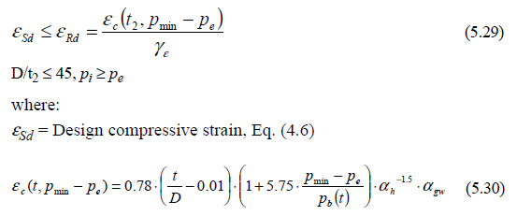  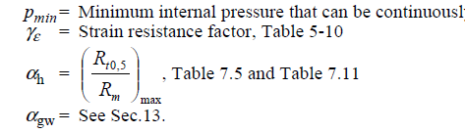  External Overpressure  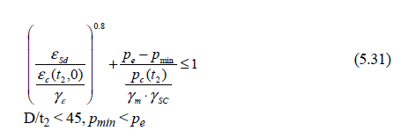 | Sec 5  D 608  Sec 5  D 609
# Utilization Circles (TBA)  Combined Effective Bending moment vs. Combined Effective Tension charts. With varying pressures | - Find the limiting BM and Effective Tension for given pressure  - Solve polynomial question to find roots and provide solution  - Pressures can range from 0 to BurstCapcity | NA

Characteristic Material Properties
The characteristic material strength fy and fu, values to be used in the limit state criteria are:

$$f_{y}=\left(SMYS-f_{y.temp}\right).∝_{U}$$

$$f_{u}=\left(SMYS-f_{u.temp}\right).∝_{U}$$
Where:
fy,temp and fu,temp are the de-rating values due to the temperature of the yield stress and the tensile strength respectively.
αU is the material strength factor

The material properties shall be selected with due regard to material type and potential temperature and/ or ageing effects and shall include:
— yield stress
— Tensile strength
— Young's modulus
— Temperature expansion coefficient.
For C-Mn steel and 13Cr this shall be considered for temperatures above 50°C, and for 22Cr and 25Cr for temperatures above 20°C.
Guidance note 1:
Field joint coating application during installation may also impose temperatures in excess of the above and shall be considered.

Guidance note 2:
If no other information of de-rating effects on the yield stress exist the recommendations for C-Mn steel, 22Cr and 25Cr Figure 2 below may be used. For 13Cr testing is normally required.

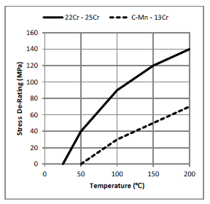
Figure 9-1 Proposed de-rating values for yield stress of C-Mn, 13Cr, 22Cr and 25Cr

Pressure containment (bursting)
The pressure containment shall fulfil the following criteria:
$$P_{li}-p_{e}≤Min\left(\frac{P_{b}(t_{1})}{γ_{m}.γ_{SC}};\frac{P_{li}}{∝_{spt}}-p_{e};\frac{P_{h}.∝_{U}}{∝_{mpt}}\right)$$

$$P_{li}-p_{e}≤Min\left(\frac{P_{b}(t_{1})}{γ_{m}.γ_{SC}};p_{h}\right)$$

The pressure containment resistance pb(t) is given by:

$$P_{b}\left(t\right)=\frac{2.t}{D-t}f_{cb}.\frac{2}{√3}$$
Where:
$$f_{cb}=Min\left[f_{y};\frac{f_{u}}{1.15}\right]$$

Local Buckling – external over pressure only (system collapse): The external pressure at any point along the pipeline shall fulfil the following criterion (system collapse check):

$$P_{e}-P_{min}≤\frac{p_{c}(t1)}{γ_{m}.γ_{SC}}$$
Where
pmin is the minimum internal pressure that can be sustained. This is normally taken as zero for as-laid pipeline.

The characteristic resistance for external pressure (pc) (collapse) shall be calculated as:

$$\left(p_{c}\left(t\right)-p_{el}(t)\right).\left(p_{c}{(t)}^{2}-p_{p}{(t)}^{2}\right)=p_{c}\left(t\right).p_{el}\left(t\right).p_{p}\left(t\right){.f}_{o}.\frac{D}{t}$$
Where:

$$p_{el}\left(t\right)=\frac{2.E.{\left(\frac{t}{D}\right)}^{3}}{1-V^{2}}$$

$$p_{p}\left(t\right)=f_{y}.∝_{fab}.\frac{2.t}{D}$$

$$f_{o}=\frac{D_{max}-D_{min}}{D}$$

The local pressure is the internal pressure at a specific point based on the reference pressure adjusted for the fluid column weight due to the difference in elevation. It can be expressed as:
$$p_{li}= p_{inc}+p_{cont}.g.(h_{ref}-h_{l}$$

$$p_{lt}= p_{t}+p_{t}.g.(h_{ref}-h_{l}$$

$$p_{inc}= p_{d}.γ_{inc}$$
where
p_{li} is the local incidental pressure
p_{inc} is the incidental reference pressure at the reference elevation
ρ_{cont} is the density of the relevant content of the pipeline
g is the gravity
h_{ref} is the elevation of the reference point (positive upwards)
h_{l} is the elevation of the local pressure point (positive upwards)
p_{lt} is the local system test pressure
p_{t} is the system test reference pressure at the reference elevation
ρ_{t} is the density of the relevant test medium of the pipeline
p_{d} is the design pressure at the pressure reference elevation
γ_{inc} is the incidental to design pressure ratio

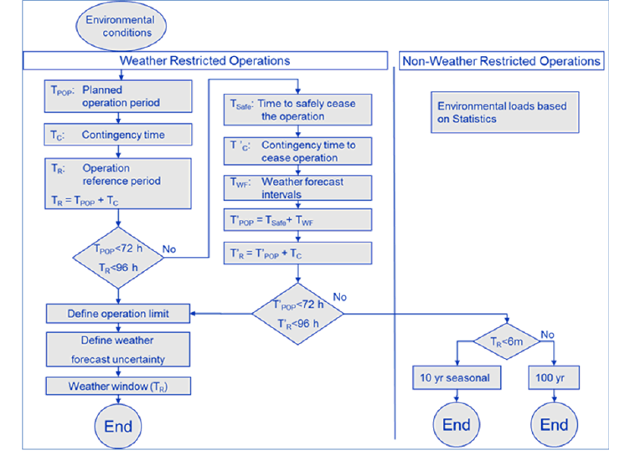
Figure 9-2 Determination of characteristic environmental load

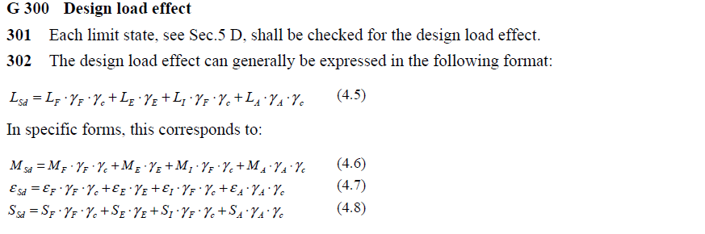

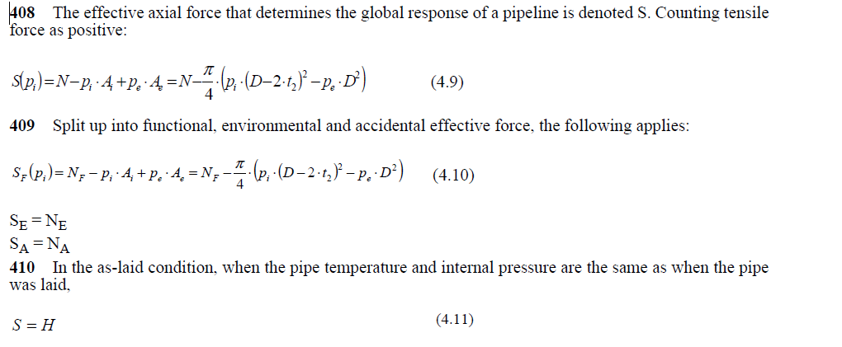

DNV-OS-F201 (Dynamic risers)

Geometrical Parameters
For burst and collapse pressure design checks the resistance shall be calculated based on
Wall thickness as follows.
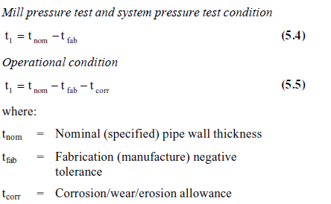

Design Load Effects
Design load effects are obtained by multiplying the load effect of each category by their corresponding load effect factor. Specific examples are given below for bending moment and effective tension.

Design bending moment for functional and environmental induced load effects:
$$M_{d}=γ_{F}.M_{F}+γ_{E}.M_{E}+γ_{A}.M_{A}$$
Where:

M_{F} = Bending moment from functional loads
M_{E} = Bending moment from environmental loads
M_{A} = Bending moment from accidental loads
Design effective tension for functional and environmental induced load effects:
$$T_{ed}=γ_{F}.T_{eF}+γ_{E}.T_{eE}+γ_{A}.T_{eA}$$

Where
T_{eF} = Effective tension from functional loads
T_{eE} = Effective tension from environmental loads
T_{eA} = Effective tension from accidental loads

The effective tension, Te is given by

$$T_{e}=T_{W}-p_{i}A_{i}+p_{e}.A_{e}$$
Where
Tw = True wall tension (i.e. axial stress resultant found by integrating axial stress over the
cross-section)
pi = Internal (local) pressure
pe = External (local) pressure
Ai = Internal cross-sectional area
Ae = External cross-sectional area

Load Effect Factors
The design load effect is used in the design checks. Several combinations may have to be checked when load effects from several load categories enter one design check. The load effect factors shown in Table
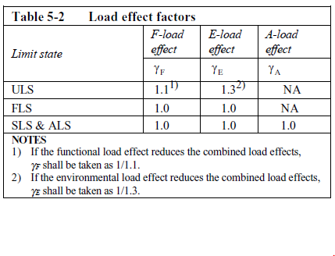

Resistance Factors
- safety class factor γ_{SC} linked to the actual safety class and accounts for the failure consequence.
- material resistance factor γm to account for material and resistance uncertainties.
- A condition factor γc to account for special conditions specified explicitly at the different limit states where relevant.

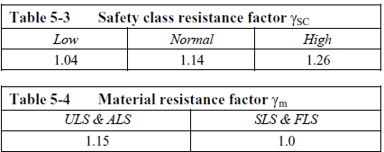

Bursting
Pipe members subjected to net internal overpressure shall be designed to satisfy the following condition at all cross sections.

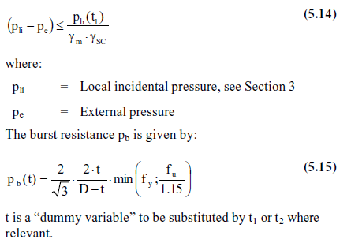

System Hoop Buckling (Collapse)
Pipe members subjected to external overpressure shall be designed to satisfy the following condition.

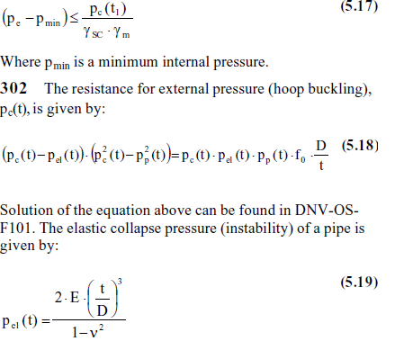

Input Data Specification

Overview
The input data required for the program is given below:

 |  | Units | Internal Pressure
Geometry
pipeNominalOD |  | m | 0.24765 | 0.24765
pipeNominalWT |  | m | 0.034925 | 0.034925
pipeMinimumWT |  | m | 0.034925 | 0.034925
pipeNominalID |  |  | 0.1778 | 0.1778
Material Properties
Yield Strength |  | ksi | 80
 |  | Pa | 5.52E+08
pipeA |  | m^2 | 0.023340213
pipeAi | Ai | m^2 | 0.024828666
pipeAo | Ao | m^2 | 0.04816888
pipeI | I | m^4 | 0.000135582
Loading
pipeExternalPressure | Po |  | 0
pipeInternalPressure | Pi | ksi | 0
pipeTensionEffective |  | N | 0
pipeMoment |  | Nm | -4.60E+05
PipeTrueTension |  |  | pipeTensionEffective + (pipeInternalPressure*pipeAi) - (pipeExternalPressure*pipeAo)
T |  |  | Pi*Ai

Design Matrix for Rigid Risers
Case | Load Category | Environmental Condition | Pressure | Reduced ensioner  Capacity or One Mooring Line Broken | C ^{a,b} f
1 | Operating | Maximum operating | Design | No | 1.0
2 | Extreme | Extreme | Design | No | 1.2
3 | Extreme | Maximum operating | Extreme | No | 1.2
4 | Extreme | Maximum operating | Design | Yes | 1.2
5 | Temporary | Temporary | Associated | No | 1.2
6 | Test^{d} | Maximum operating | Test^{d} | No | 1.35
7 | Survival | Survival | Associated | No | 1.5
8 | Survival | Extreme | Associated | Yes | 1.5
9 | Fatigue | Fatigue | Operating | No | Note^{c}

References.
- API RP 2RD 1st Ed with errata (2009) Design of Risers for FPSs and TLPs (June 2009)
- Dropbox\0119 Programming\001 VMStress2RD\Ref
- API STD 2RD 2nd Ed (2013) Dynamic Risers for Floating Production Systems
- API RP 1111 4th Ed (2009) Design, Construction, Operation, and Maintenance of Offshore Hydrocarbon Pipelines (Limit State Design)
- ASME B31.8 (2007) Gas Transportation and Distribution Piping Systems
- DNV OS F201 (2001) Dynamic Risers
- DNV OS F201 (2010) Dynamic Risers

– PROGRAM HISTORY

TBA

Revision Date | Features

Table 4-1.Program History

- ERROR LOG for Programs
Table 4-2. Code Error.
Project Folder | Python Program | Environment Pacakage | Run Instructions | OUTPUT/ Error
002_Non-Linear_Stress_Strain_Ratio | Stress-StrainCurvesCalculation.py | no env | 1)change directory = "F:\aceengineer\002_Non-Linear_Stress_Strain_Ratio 2)Run the program = "Stress-StrainCurvesCalculation.py" | 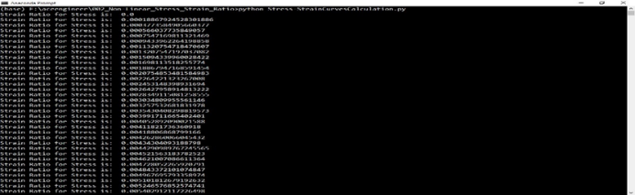
010_ProjectSchedule | projectSchedule_D01.py | name = ProjectSchedule channels = defaults dependencies = python=3.6 pip = projectscheduler | 1) change directory = "F:\aceengineer\010_ProjectSchedule 2)Run the program = "projectSchedule_D01.py" | 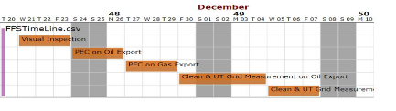
015_Finance | driver.py | SET py_environment=MySQL_env, py_program=dynaCard.py, CALL c:\data\Continuum\Anaconda3\Scripts\activate.bat %py_environment%,  python %py_program% | 1)change directory = "F:\aceengineer\015_Finance 2)Run the program = "driver.py" | $ python driver.py  Traceback (most recent call last):  File "driver.py", line 14, in <module>  print ("Getting Data from : " + configData.dataSource[0])  TypeError: 'NoneType' object is not subscriptable
015_Plate_Buckling | PlateBuckling_212.py | SET py_environment=DataLoader_env,  CALL conda create -n %py_environment% python=3.5,  activate %py_environment% | 1) change directory = "F:\aceengineer\015_Plate_Buckling 2)Run the program = "PlateBuckling_212.py" | 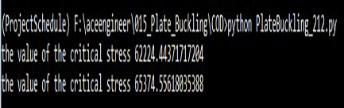
017_Fatigue_Curves | fatigue.bat | no env | 1)change directory = "F:\aceengineer\017_Fatigue_Curves 2)Run the program = "fatigue.bat" | (base) F:\aceengineer\017_Fatigue_Curves\COD>fatigue.bat  (base) F:\aceengineer\017_Fatigue_Curves\COD>call python FatigueBasiccurve.py  (base) F:\aceengineer\017_Fatigue_Curves\COD>call python FatiguecurveRawdata.py  C:\Users\AceEngineer-002\Anaconda3\lib\site-packages\pandas\io\excel.py:329: FutureWarning: The `sheetname` keyword is deprecated, use `sheet_name` instead **kwds)  (base) F:\aceengineer\017_Fatigue_Curves\COD>call python LinearslopeCal.py  (base) F:\aceengineer\017_Fatigue_Curves\COD>call python ll2.py  (base) F:\aceengineer\017_Fatigue_Curves\COD>call python Shear7dataCal.py  C:\Users\AceEngineer-002\Anaconda3\lib\site-packages\pandas\core\indexing.py:189: SettingWithCopyWarning:  A value is trying to be set on a copy of a slice from a DataFrame  See the caveats in the documentation: http://pandas.pydata.org/pandas-docs/stable/indexing.html#indexing-view-versus-copy self._setitem_with_indexer(indexer, value)
API579 | runBatch.bat | name:API579  channels:defaults,conda-forge  dependencies:python=3.6,pyyaml,yaml,oyaml,matplotlib,scipy,pandas,python-docx  pip:imgkit,openpyxl,xlrd | 1)change directory = F:\aceengineer\API579 2)Run the program = "runBatch.bat" | 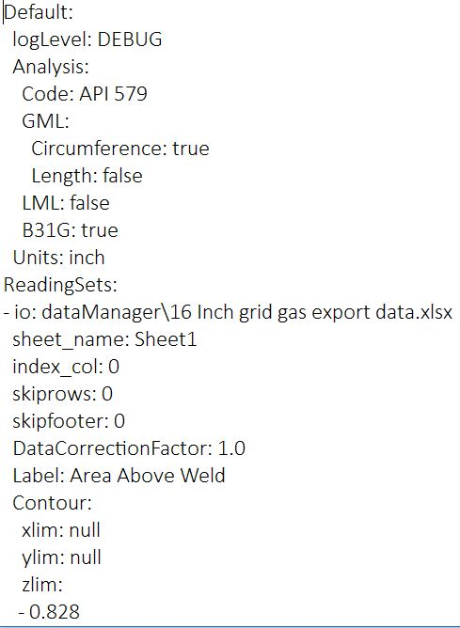
API-RP-2RD | APIRP2RD-VA.py | name:pipeUtilization  channels:defaults,dependencies:  python=3.6,yaml | 1)change directory = F:\aceengineer\API-RP-2RD 2)Run the program = " APIRP2RD-VA.py " | 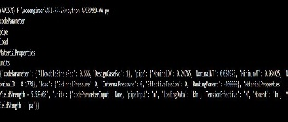
API-STD-2RD | APISTD2RD.py | name:pipeUtilization  channels:defaults  dependencies:python=3.5.5=h0c2934d_2,yaml=0.1.7  matplotlib=2.2.3,pandas=0.23.4,numpy | 1)change directory = "F:\aceengineer\API-STD-2RD 2)Run the program = "APISTD2RD.py" | 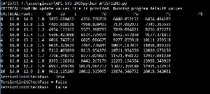
ASMEB31 | runBatch.bat | name:PipeCapacity  channels:defaults  dependencies:python=3.6  pyyaml,yaml,oyaml,matplotlib  scipy,pandas,imgki | 1)change directory = "F:\aceengineer\ASMEB31 2)Run the program = " runBatch.bat " | 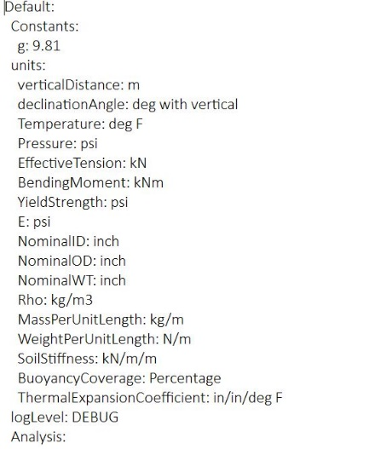
Burst_Collapse_Code | APIST2RD_BurstandCollapse.py | no env | 1) change directory = "F:\aceengineer\Burst_Collapse_Code 2)Run the program = "APIST2RD_BurstandCollapse.py" | 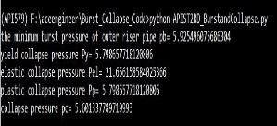
Catenary | catenaryRiser.py | name:catenary  channels:defaults  dependencies:python=3.6,pyyaml,yaml  matplotlib,scipy,pandas, xlrd  pip:oyaml,imgkit | 1)change directory = "F:\aceengineer\catenary 2)Run the program = "catenaryRiser.py" | 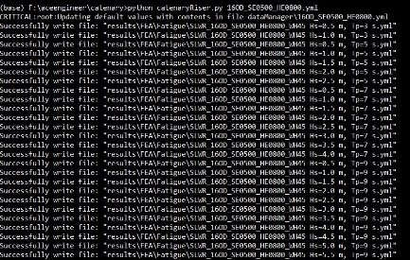
DNV-OS-F101 | DNVOSF101Analysis.py | SET py_environment=PipeCapacity_env,  CALL conda create -n %py_environment% python=3.5  CALL activate %py_environment% | 1)change directory = "F:\aceengineer\DNV-OS-F101 2)Run the program = "DNVOSF101Analysis.py" | 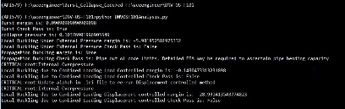
OrcaFlex-Post | OrcaFlexAnalysis.py | name:OrcaFlex  channels:defaults  dependencies: python=3.6, pyyaml,yaml  oyaml, matplotlib,scipy, pandas  numpy | 1)change directory = "F:\aceengineer\OrcaFlex-Post 2)Run the program = "OrcaFlexAnalysis.py" | 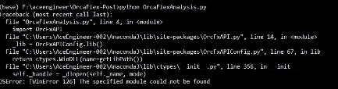
pipeOvality | Ovality Formula File.py | no env | 1)change directory = "F:\aceengineer\pipeOvality” 2)Run the program = "Ovality Formula File.py" | 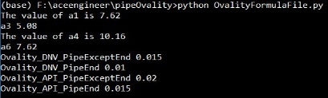
taperDesign | taperDesign.py | no env | 1)change directory = "F:\aceengineer\taperDesign” 2)Run the program = "taperDesign.py" | 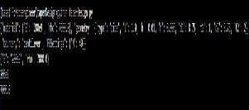

Calculation Errors

The typical errors encountered while running the calculation program are given in this section.

-test cases.

The program got to handle discontinuities as shown in figure below.

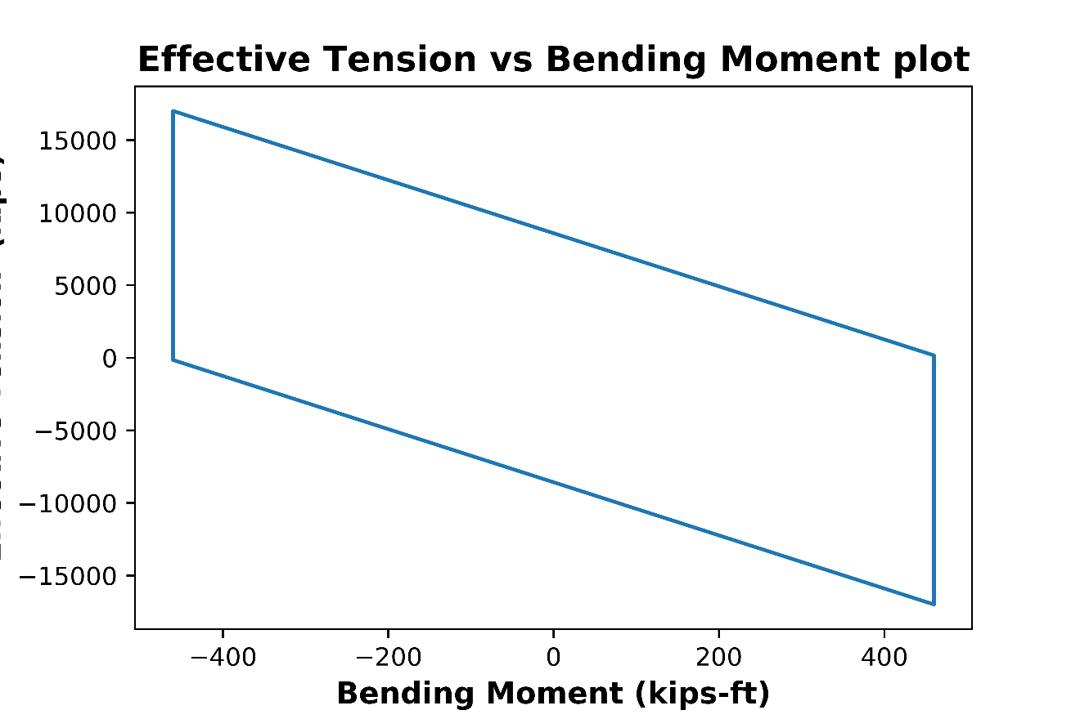

Table 5.Test Cases.

validation

